**40**

**Quantum Mechanics**

|  |
| --- |
| **CHAPTER OUTLINE** |

40.1 The Wave Function

40.2 Analysis Model: Quantum Particle Under Boundary Conditions

40.3 The Schrödinger Equation

40.4 A Particle in a Well of Finite Height

40.5 Tunneling Through a Potential Energy Barrier

40.6 Applications of Tunneling

40.7 The Simple Harmonic Oscillator

* An asterisk indicates a question or problem new to this edition.

|  |
| --- |
| **SOLUTIONS TO THINK-PAIR-SHARE AND ACTIVITIES** |

**\*TP40.1** **Conceptualize** The proton in the nucleus is constrained to move in a small region of space. Is the particle in a box a good model?

**Categorize** This problem involves the *quantum particle under boundary conditions* model, applied to the particle in a one-dimensional box.

**Analyze** (a) Using Equation 40.14, find the energy difference between a general state described by quantum number *n* and the *n* = 1 state of the particle in a box:

 (1)

Substitute numerical values for a proton in the box:



(b) Set the energy difference equal to the photon energy and solve for the wavelength:

 (2)

Substitute numerical values:



(c) Consulting Figure 33.13, we find that this wavelength lies deeply in the range of gamma radiation.

**Finalize** While the particle in a box is a reasonable first step in modeling the particles in the nucleus, reality is complicated by other effects, such as, for example, *spin-orbit coupling*. Section 43.3 discusses more details about nuclear models. ]

*Answers:* (a) 6.14 MeV (b) 202 fm (c) gamma radiation

**\*TP40.2** **Conceptualize** The wave functions for the particle in a box are shown in Figure 40.4a. Figure 40.4b shows the probability of finding the particle *at* any given position. In this problem, we are trying to find the probability that the particle is anywhere to the *left* of a given position.

**Categorize** This problem involves the *quantum particle under boundary conditions* model, applied to the particle in a one-dimensional box.

**Analyze** (a) Use the probability expression in Equation 40.6 to find the probability that the particle is between *x* = 0 and 

 (1)

Substitute the wave function for the particle in a box from Equation 40.13, using *n* = 1 for the ground state:

 (2)

Carry out the integration in Equation (2):



(b) Let’s test the function at 



This is a reasonable result. If  there is no part of the box to the left of  because we are at the left edge of the box, and the probability must be zero.

Now, for ,



This is a reasonable result. At the middle of the box, due to the symmetry of the wave function, the probability should be one-half that the particle is to the left of the middle.

Now, for 



This is also reasonable. The value of  = *L* puts us at the right edge of the box, so the entire box is to the left of . The particle must be in the box *somewhere*, so the probability is 1.

(c) For the probability to be four times as great for the particle to be to the left of  than to the right, then the probability must be  = 0.800 ( to the left,  to the right). Substitute this result into Equation (2):



Uh-oh. This is a transcendental equation. While you might try to solve this with various techniques, here’s another idea. Let’s graph Equation (2) and find the value of  /*L* for which the probability is 0.800:

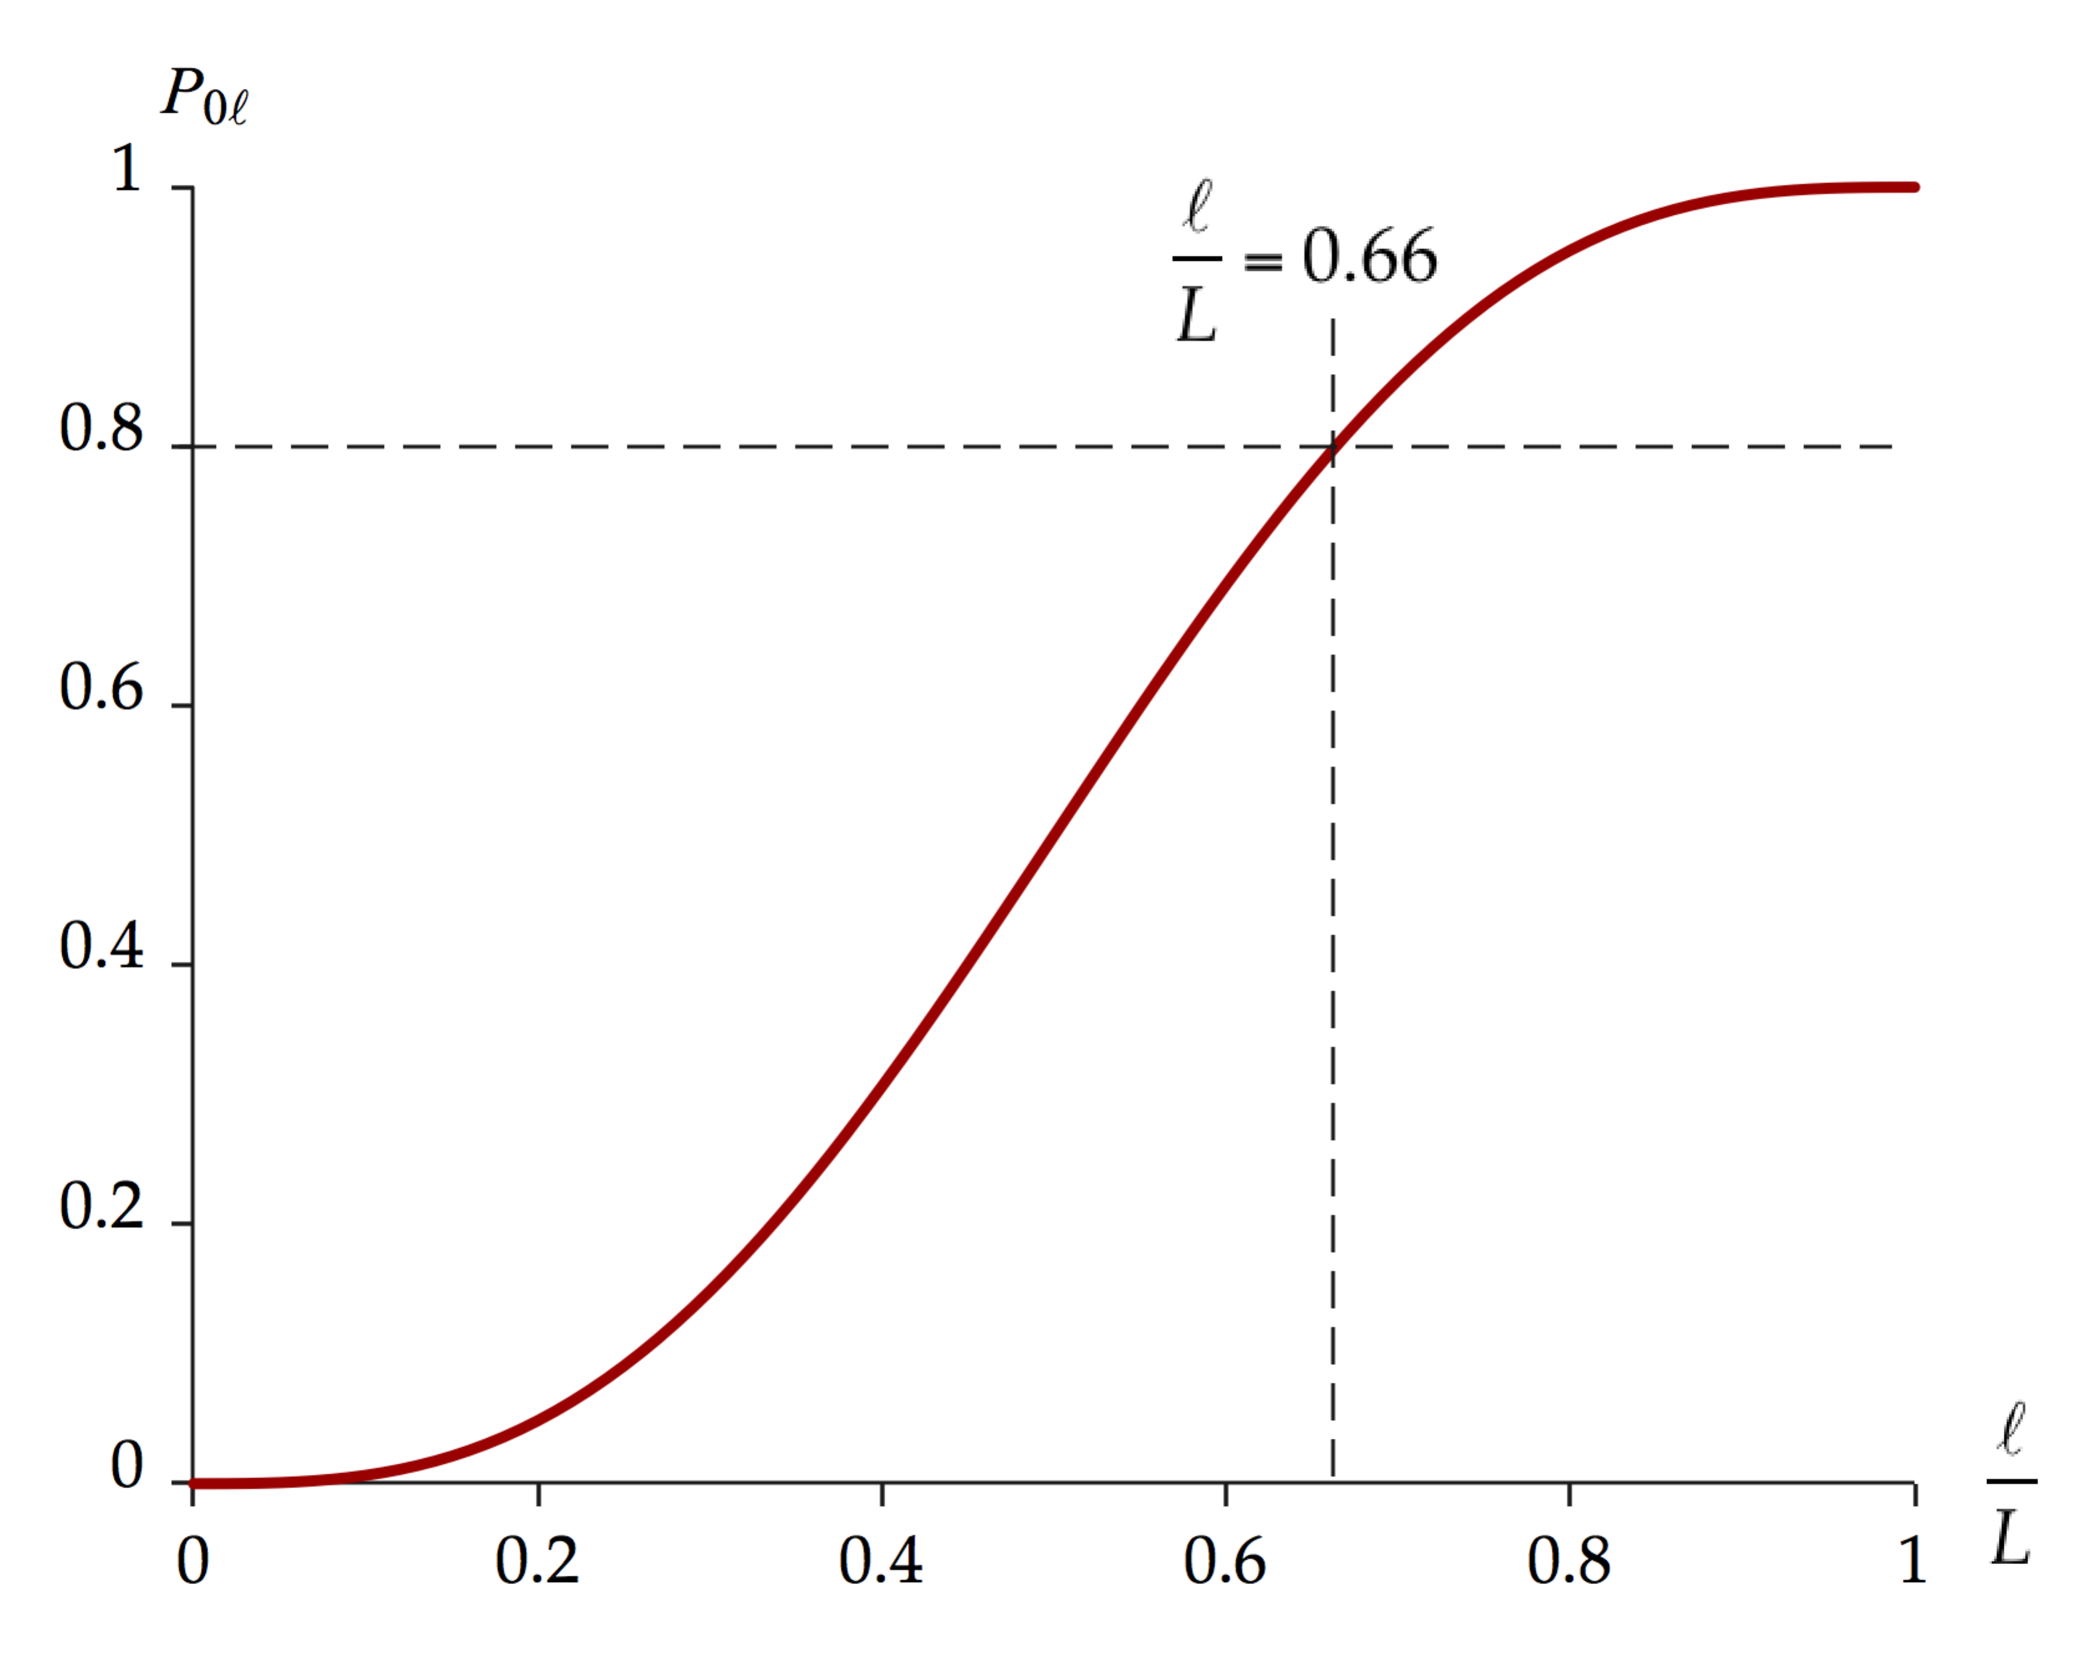

The graph gives a value of  = 0.66*L*, where we have kept only two significant figures due to the uncertainty in reading the graph.

**Finalize** A more detailed analysis of part (c) shows that  = 0.800 at  = 0.663 683 5*L*.]

*Answers:* (a)  (b) , , and  (c)  = 0.66*L*

**\*TP40.3** **Conceptualize** Review Section 40.4 to be sure you understand the particle in a finite well. Because the wave function does not go to zero at the ends of the well as it does for the infinite well, the evaluation of the quantized energies of the particle will not be as simple.

**Categorize** The electron in the finite well is modeled as a *quantum particle under boundary conditions.*

**Analyze** (a) The cosine function in the suggested solution is symmetric around *x* = 0 while the sine function is antisymmetric. Therefore, for symmetric solutions, we set *F* = 0:



Apply the boundary conditions for the wave functions:

 (1)

 (2)

The right side of Equation (1) is the same as the left side of Equation (2), so we see that *A* = *B* for symmetric solutions.

Apply the boundary conditions for the derivatives of the wave functions:

 (3)

 (4)

Equations (3) and (4) are the same. Divide Equation (3) by Equation (2), noting that *B* = *A*:

 (5)

Now consider the antisymmetric solutions. Antisymmetric solutions involve a sine function. Therefore, we set *G* = 0 in the general solutions, and antisymmetric solutions are given by



Apply the boundary conditions for the wave functions:

 (6)

 (7)

The right side of Equation (6) is the negative of the left side of Equation (7), so we see that *A* = –*B* for antisymmetric solutions.

Apply the boundary conditions for the derivatives of the wave functions:

 (8)

 (9)

Equations (8) and (9) are the same. Divide Equation (8) by Equation (7), noting that *B* = –*A*:

 (10)

Equations (5) and (10) are the requested equations.

(b) Use the definitions of *a* and *b* given in the problem and then use Equations 40.17 and 40.29:



Therefore,

 (11)

where

 (12)

(c) From the definitions of *a* and *b* in part (b), we see that

 (13)

Therefore, Equations (5) and (10) become

 (14)

 (15)

(d) In the definition of *b* in part (b), substitute for *k* from Equation 40.17:



(e) We first evaluate the value of *r* for the data provided in the problem statement, using Equation (12):



Using a spreadsheet or graphing software and the value of *r*, graph the left side of Equation (14) and (15) versus *b*. On the same graph, graph the right sides of Equations (14) and (15) versus *b*, keeping only positive values. This graph appears below.

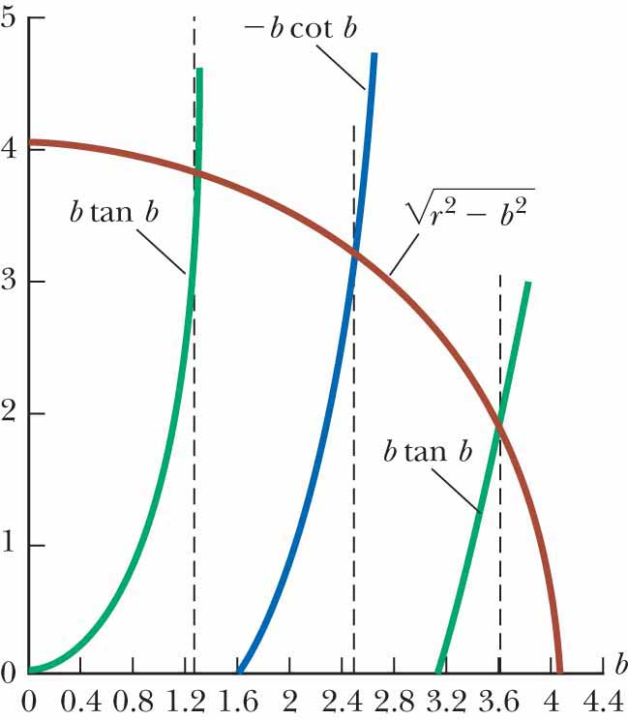

Notice the circular shape of the red line, representing Equation (11). The intersections of the red circle with the green and blue lines represent possible states of the system.

(f) The vertical black lines show points where the curves cross. Reading from the horizontal axis, we find



(g) Because there are three points at which the curves cross, there are three quantized energies for the electron in the well.

(h) Using Equation (16), we have



Substitute numerical values, reading *r* from the intersection of the red curve with the *x* or *y* axes, or evaluating it from Equation (12):



**Finalize** This was a long problem, but we succeeded in finding the quantized energies! If we find the first three quantized energies of an *infinite* well of the same width, we find them to be 1.50 eV, 6.02 eV, and 13.5 eV. The finite well clearly lowers the quantized energies and restricts them to a finite number, three in this case. We can explain the lowering of energy conceptually by noticing that the wavelengths of the sinusoidal waves inside the well in Figure 40.7a are longer than those in Figure 40.4, because the wave function extends beyond the boundaries. A longer wavelength corresponds to a lower energy.]

*Answers:*

(e)



**ANS.FIG. TP40.3**

(f) 1.26, 2.48. 3.605 (g) three (h) 0.968 eV, 3.75 eV, 7.92 eV

|  |
| --- |
| **SOLUTIONS TO END-OF-CHAPTER PROBLEMS** |

Section 40.1 The Wave Function

P40.1 (a) The wave function,



will go through one full cycle between *x*1 = 0 and (5.00  1010)*x*2 = 2 The wavelength is then



To say the same thing, we can inspect to see that the wave number is *k* = 5.00  1010 m–1 = 

(b) Since  = *h*/*p*, the momentum is



(c) The electron’s kinetic energy is



[We use *u* to represent the speed of a particle with mass in chapters 38, 39, and 40.]

P40.2 (a) See ANS. FIG. P40.2 for a graph of  for the range .

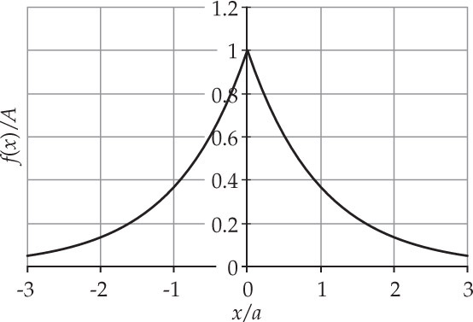

**ANS. FIG. P40.2**

(b) Normalization requires





(c) 

P40.3 The probability is given by





Section 40.2 Analysis Model: Quantum Particle Under Boundary Conditions

P40.4 The energy of the photon is



The allowed energies of the proton in the box are



The smallest possible energy for a transition between states is from   
*n* = 1 to *n* = 2, which has energy



The photon does not have enough energy to cause this transition. The photon energy would be sufficient to cause a transition from *n* = 0 to   
*n* = 1, but the *n* = 0 state does not exist for the particle in a box.

P40.5 (a) The energy of a quantum particle confined to a line segment is



Here we have for the ground state



and for the first and second excited states, which are states 2 and 3,



(b) They do; the MeV is the natural unit for energy radiated by an atomic nucleus.

Stated differently: Scattering experiments show that an atomic nucleus is a three-dimensional object always less than 15 fm in diameter. This one-dimensional box 20 fm long is a good model in energy terms.

P40.6 The ground state energy of a particle (mass *m*) in a 1-dimensional box of width *L* is .

(a) For a proton (*m* = 1.67 × 10–27 kg) in a 0.200-nm wide box:



(b) For an electron (*m* = 9.11 × 10–31 kg) in the same size box:



(c) The electron has a much higher energy because it is much less massive.

**P40.7** (a) From Equation 40.14, the allowed energy levels of an electron in a box is

 *n* = 1, 2, 3, . . .

Substituting numerical values,



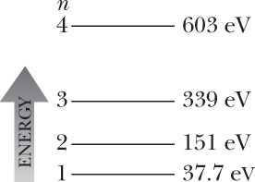

P40.8 (a) The classical kinetic energy of the particle is



1. The length *L* can be found from



Solving,



(c) 

P40.9 (a) From  with  , so the uncertainty in momentum must be at least .

(b) Its energy is all kinetic, so



(c) Compare the result of part (b) to the result *h*2/8*mL*2 for the wave function as a standing wave. This estimate is too low by  times, but it correctly displays the pattern of dependence of the energy on the mass and on the length of the well.

P40.10 Normalization requires 



P40.11 (a) The expectation value is 



From integral tables, we find that



(b) The probability of finding the particle in the range   
0.490*L* ≤ *x* ≤ 0.510*L* is



(c) The probability of finding the particle in the range   
0.240*L* ≤ *x* ≤ 0.260*L* is



(d) 

P40.12 (a) The most probable positions of the particle are *x* = *L*/4, *L*/2, and 3*L*/4.

(b) We look for sin (3*πx*/*L*) taking on its extreme values 1 and –1 so that the squared wave function is as large as it can be. The result can also be found by studying Figure 40.4b. The most probable locations are at the antinodes of the standing wave pattern *n* = 3, which has three antinodes that are equally spaced, one at the center, and two a distance *L*/4 from either end.

**P40.13** (a) The probability is



(b) The probability density is symmetric about . Thus, the probability of finding the particle between  and *x* = *L* is the same, 0.196. Therefore, the probability of finding it in the range  is .

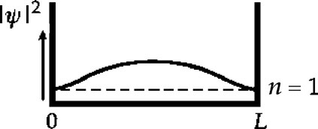

**ANS. FIG. P40.13(b)**

**\*P40.14 Conceptualize** The electron in the atom is constrained to move in a small region of space. Is the particle in a box a good model?

**Categorize** This problem involves the *quantum particle under boundary conditions* model, applied to the particle in a one-dimensional box.

**Analyze** Using Equation 40.14, find the energy difference between a general state described by quantum number *n* and the *n* = 1 state of the particle in a box and set the energy difference equal to the photon energy emitted by that transition:

 (1)

Solve Equation (1) for the length of the box:

 (2)

Substitute numerical values for the transition *n* = 2 to *n* = 1, using the wavelength given in the problem statement:



(b) Solve Equation (2) for the wavelength:

 (3)

Substitute numerical values for the transition *n* = 3 to *n* = 1, using the box length found in part (a):



The length of the box in part (a) is indeed very similar to atomic “sizes.” However, the predicted wavelength in part (b) does not agree with the experimentally measured wavelength. And it gets worse. For the *n* = 5 to *n* = 1 transition, the particle-in-a-box model predicts a wavelength of 15.2 nm, while the measured wavelength is 95.0 nm. Take a look ahead at Figure 41.8, showing the quantized energy levels of the hydrogen atom. As energy goes up, the energy levels get closer together and approach a maximum value. Figure 40.5 for the particle in a box, however, shows energy levels getting *farther apart* as the energy goes up. This is a serious discrepancy that dooms the particle-in-a-box model for the hydrogen atom.

**Finalize** In some ways, the particle-in-a-box model for the hydrogen atom is similar to the Thomson model of the atom, which we addressed in Think–Pair–Share Problem 23.1. In that problem, we used a different model to estimate the size of the atom and obtained a similar result. But, like the particle-in-a-box model, the Thomson model does not give correct predictions beyond the size of the atom.]

*Answers:* (a) 0.332 nm (b) 45.6 nm, quite different from 102.6 nm

Section 40.3 The Schrödinger Equation

**P40.15** (a) Given the function



Its derivative with respect to *x* is



And its second derivative is



The Schrödinger equation is satisfied if

 where *U* = 0:



This is true as an identity (functional equality) for all *x* if , which is true because *E* = *K* + *U* = *K* + 0 = *K*, and

 

(b) From part (a), 

**P40.16** From  **[1]**

we evaluate



and  **[2]**

We substitute equations [1] and [2] into the Schrödinger equation, so that Equation 40.15,



becomes the test equation

 **[3]**

The wave function  is a solution to the Schrödinger equation if equation [3] is true. Both sides depend on *A*, *x*, and *t* in the same way, so we can cancel several factors, and determine that we have a solution if



But this is true for a nonrelativistic particle with mass in a region where the potential energy is zero, since



where *K* is the kinetic energy. Therefore, the given wave function does satisfy Equation 40.15.

**P40.17** (a) Setting the total energy *E* equal to zero and rearranging the Schrödinger equation to isolate the potential energy function gives



If 

Then,



or 

and 

(b) U(x) is sketched in ANS. FIG. P40.17(b).

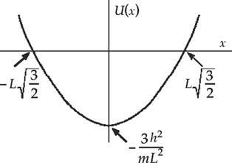

**ANS. FIG. P40.17(b)**

**P40.18** (a) These are standing wave patterns with nodes at the ends and *n* antinodes.

For *n* = 1, the wave function is



and the probability density is



For *n* = 2, the wave function is



and the probability density is



For *n* = 3, the wave function is



and the probability density is



(b) The wave functions and probability densities are shown in ANS. FIG. P40.18(b).

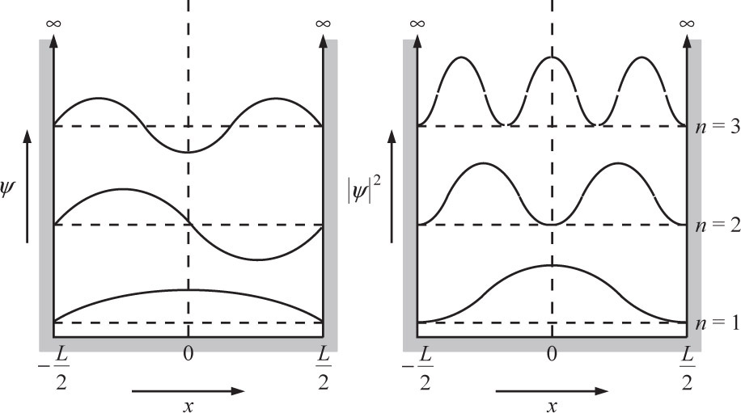

**ANS. FIG. P40.18**

**Section 40.4 A Particle in a Well of Finite Height**

**P40.19** (a) For *n* = 4, the wave function has two maxima and two minima (four extrema), as shown in the left-hand panel of ANS. FIG. P40.19.

(b) For *n* = 4, the probability function has four maxima. as shown in the right-hand panel of ANS. FIG. P40.19.

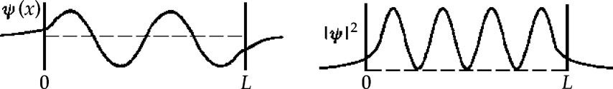

**P40.20** (a) See ANS. FIG. P40.20(a).

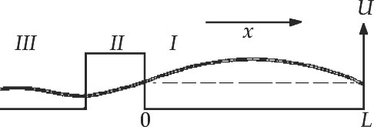

**ANS. FIG. P40.20 (a)**

(b) The wavelength inside the box is 2*L*. The wave function penetrates the wall, but the wavelength of the transmitted wave traveling to the left is the same, , because *U* = 0 on both sides of the wall, so the energy and momentum and, therefore, the wavelength, are the same.

Section 40.5 Tunneling Through a Potential Energy Barrier

**P40.21** (a)  where



and 

(b) We require  Taking logarithms,



Section 40.6 Applications of Tunneling

**P40.22** With transmission coefficient *e*–2*CL*, the fractional change in transmission is



Section 40.7 The Simple Harmonic Oscillator

**P40.23** The longest wavelength corresponds to minimum photon energy, which must be equal to the spacing between energy levels of the oscillator. From  we have



or



P40.24 The longest wavelength corresponds to minimum photon energy, which must be equal to the spacing between energy levels of the oscillator, which is (from Equation 40.34)



**P40.25** (a) With  the normalization condition  becomes



where Table B.6 in Appendix B was used to evaluate the integral.

Thus, .

(b) For small *δ*, the probability of finding the particle in the range  is



P41.26 (a) The wave function is given by  so



and



Substitute into Equation 40.30:



For this to be true as an identity, the coefficients of like terms must be the same for all values of *x*. So we must have both

 and 

(b) Therefore,  and 

(c) The energy levels are , so *n* = 1, which corresponds to the .

P40.27 (a) With  and , the average value of *x*2 is  and the average value of  is  We know .

The average of the energy is constant:



We rewrite the last equation as 

(b) To minimize *E* as a function of  we require



Then



and



Therefore, 

*P40.28 **Conceptualize** Be sure you are clear on the notion of *degeneracy*. The states we have seen in this chapter have a degeneracy of 1—that is, a given energy level is associated with only *one* state. In Chapter 41, we will see that the hydrogen atom has energy levels with higher degeneracies.

**Categorize** We model the system as a *quantum harmonic oscillator*, using the suggestion that the three-dimensional oscillator is a combination of three one-dimensional oscillators.

**Analyze** Let's begin with the lowest possible energy. For each one-dimensional oscillator, the lowest value of *n* is *n* = 0. Therefore, the lowest energy for the three-dimensional oscillator is found by using the quantum numbers



From the expression for the energy, this gives us



There is only one way to achieve this energy, so the degeneracy is 1. Higher energies will be found by increasing the value of . Because each of the values of *n* is an integer, the sum must be an integer. Let’s let the value of this sum be the next highest possible value . We see that there are three ways to do this:



All three of these choices give an energy of



Therefore, the degeneracy of this energy level is 3. Let’s increase the sum by 1 again: . There are six ways to do it:



All six of these choices give an energy of



Therefore, the degeneracy of this energy level is 6. Let’s increase the sum by 1 again so that . Aha, we find several ways to do this:



All of these choices give an energy of



Counting up the possibilities, we see that this energy level has a degeneracy of 10.

**Finalize** You can probably see that the degeneracies will rise rapidly, corresponding to the large number of ways that you can add three integers to arrive at the same sum.]

*Answers:* energy, , degeneracy 1; energy, , degeneracy 3; energy, , degeneracy 6; energy, , degeneracy 10

**P40.29** Equation 40.32 is  so

 and 

Substitute into Equation 40.30:



which is satisfied provided that .

**P40.30** (a) For the center of mass to be fixed, . Then



and



Also,



Substitute for  and :



(b) Because the total energy is constant



This is the condition for simple harmonic motion; the acceleration of the equivalent particle is a negative constant times the displacement from equilibrium.

(c) By identification with 

 and 

**Additional Problems**

**P40.31** (a) From Equation 41.4 for  the first and second derivatives are

 and 

Then



(b) For 

 and 

Then, similarly to the proof in part (a),



**P40.32** If we had *n* = 0 for a quantum particle in a box, its momentum would be zero. The uncertainty in its momentum would be zero. The uncertainty in its position would not be infinite, but just equal to the width of the box. Then the uncertainty product would be zero, to violate the uncertainty principle. The contradiction shows that the quantum number cannot be zero. In its ground state the particle has some nonzero zero-point energy.

**P40.33** *T* = *e*–2*CL*, where  and where *m* is in kilograms, and *U* and *E* are in joules.

1. We compute



Then,



and 

1. We compute



Then,



and 

(c) We compute



Then,



and 

(d) We compute



Then,



**P40.34** From Equation 40.14, the energy levels of an electron in an infinitely deep potential well are proportional to *n*2. If the energy of the ground state, *n* = 1, is *E*1 = 0.300 eV, the energy levels of the states *n* = 2, 3, and 4 are



(a) For the transition from the *n* = 3 level to the *n* = 1 level, the electron loses energy



(b) For the transition from level 2 to level 1,

*E* = 1.20 eV – 0.300 eV = 0.900 eV

and



This photon, with wavelength greater than 700 nm, is in the infrared region.

In like manner, we find

for 3 to 2: 

for 4 to 1: 

for 4 to 2: 

for 4 to 3: 

**\*P40.35 Conceptualize** The reason that the picture slips into the configuration shown in Figure P40.35b is that it represents a lower gravitational potential energy of the picture–Earth system. Because of the lack of friction, as soon as the symmetric position in Figure P40.35a is disturbed, the wire slips on the nail, and gravity pulls the picture until it looks like Figure P40.35b.

**Categorize** The combination of the picture and the Earth is a two-state quantized isolated system.

**Analyze** You can raise the picture from the state in Figure P40.35b to that in Figure P40.35a by doing work on the picture. The appropriate reduction of Equation 8.2 is

 (1)

where *W* is the energy we must put into the system. Expand the term ∆*Ug*:

 (2)

where the subscripts *a* and *b* refer to the two parts of Figure P40.35. Evaluate the initial and final potential energies relative to *Ug* = 0 if the center of mass of the picture were at the nail, recognizing that the center of mass is below the nail by about half the *height* in configuration *a* and by about half the *diagonal* in configuration *b*:



**Finalize** What if the wire is very long? For example, suppose the picture hangs from a picture rail near the ceiling. Is there still a two-state system?]

Answer: 

**P40.36** Suppose the marble has mass 20 g. Suppose the wall of the box is 12 cm high and 2 mm thick. While it is inside the wall,



and



Then,



and the transmission coefficient is



P40.37 (a) From Equation 41.14, the allowed energy levels are

 *n* = 1, 2, 3, …

The energy of the absorbed photon is



We determine the length of the box from



(b) The energy lost during the *n* = 3 to *n* = 2 transition is



The wavelength of the emitted photon is then



P40.38 

For a one-dimensional box of width *L*, from Equation 41.18,



With the substitution



the integral becomes (from integral tables)



P40.39 (a) The requirements that  and  are still valid. From the relativistic energy of the particle,



its kinetic energy is therefore



(b) Taking *L* = 1.00 × 10–12 m, *m* = 9.11 × 10–31 kg, and *n* = 1, we find



(c) The particle’s nonrelativistic energy is 

Comparing this to *K*1, we see that this value is too large by .

**P40.40** Looking at Figure 40.7, we see that wavelengths for a particle in a finite well are longer than those for a particle in an infinite well. Therefore, the energies of the allowed states should be lower for a finite well than for an infinite well. As a result, the photons from the source have too much energy to be absorbed or, equivalently, the photons have a frequency that is too high. In order to lower their apparent frequency using the Doppler shift, the source would have to move *away* from the particle in the finite square well, not *toward* it.

**\*P40.41 Conceptualize** Classically, as long as *E* > *U*, the particles would all pass the step and travel with a reduced speed. Quantum mechanically, a change in the potential results in both transmission and reflection, just like a change in the medium causes both transmission and reflection for mechanical waves.

**Categorize** The particles are modeled as quantum particles, encountering a potential step.

**Analyze** Because the problem asks for energies, let us modify the reflection coefficient to be expressed in terms of energies. We first divide the numerator and denominator of the reflection coefficient by *k*12:

 (1)

Now, evaluate the ratio of *k* values:

 (2)

where *f* is the ratio of energies, *U*/*E*. Substitute Equation (2) into Equation (1):

 (3)

(a) If half of the incident particles reflect from the step, we must have *R* = . Therefore, from Equation (3),

 (4)

Take the square root of both sides of Equation (4), choosing the positive root:

 (5)

Solve for *f*:



Now, because *f* = *U*/*E*, we have



(b) The fraction *a* by which the kinetic energy of the particles changes upon being transmitted through the step is



Substitute the value of *E* in part (a):



Set this result equal to the ratio of kinetic energies of the particles in terms of their speeds:



**Finalize** Notice that the particle energy must be close to the potential height for a significant number of particles to be reflected. In part (a), to reflect 50% of the particles, the incident energy is only 3% larger than the barrier height. At much higher energies, a small fraction of the particles is reflected. The graph below shows that the reflection coefficient falls rapidly as the energy *E* increases.

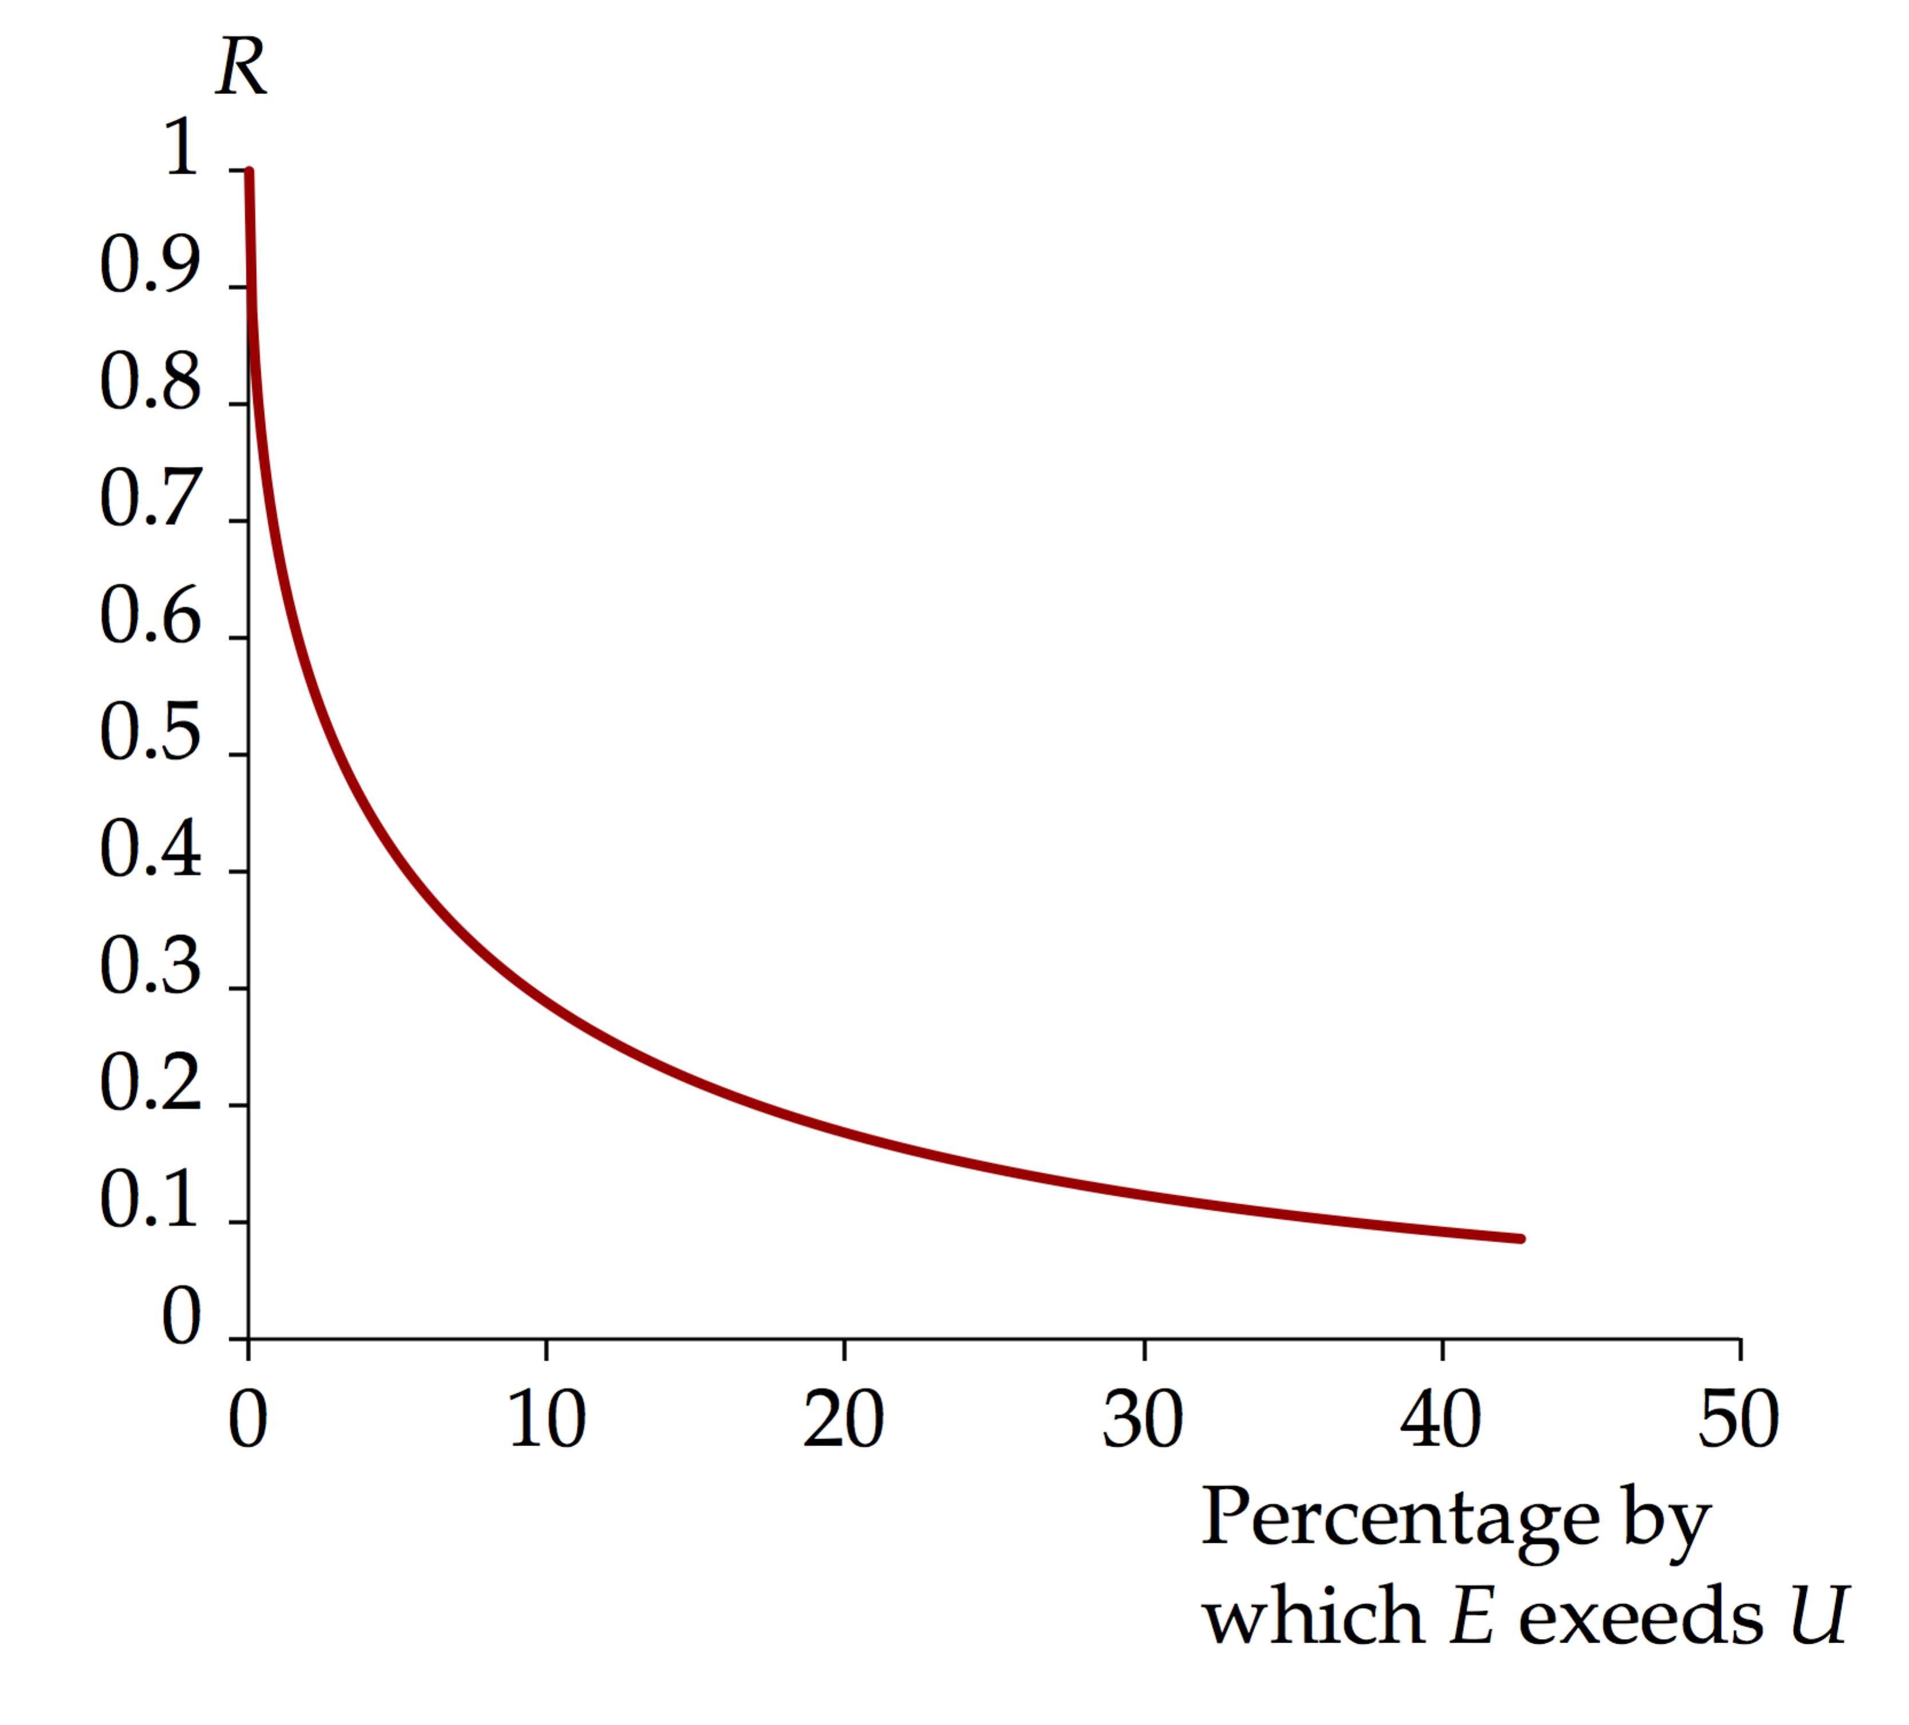

The remarkable thing is that *any* particles are reflected. Imagine rolling a bowling ball in the street toward a disabled ramp in a sidewalk, with plenty of energy for the ball to roll up on the sidewalk, and have it reflect from the ramp! This is just one example of the surprising nature of quantum mechanics.]

*Answers:* (a) 1.03*U* (b) 0.172

**P40.42** (a) Taking *Lx* = *Ly* = *L*, we see that the expression for *E* becomes



The general form of the wave function is



For a normalizable wave function, neither *nx* nor *ny* can be zero, otherwise *ψ* = 0.

(b) The ground state corresponds to .

(c) The energy of the ground state is



(d) For the first excited state, *nx* = 1 and *ny* = 2, or *nx* = 2 and *ny* = 1.

(e) For the second excited state, *nx* = 2 and *ny* = 2.

(f) The second excited state, corresponding to *nx* = 2, *ny* = 2, has an energy of



(g) The energy difference between the ground state and the second excited state is



(h) 

**P40.43** (a) For a particle with wave function



The probability densities are

 for *x* < 0

and  for *x* > 0.

ANS. FIG. P40.43. shows a sketch of the probability density for this particle.

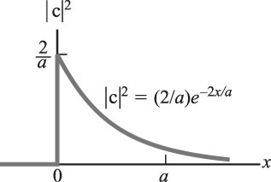

**ANS. FIG. P40.43**

(b) The probability is obtained from



1. For the wave function to be normalized, we require



Performing the integration gives



1. The probability is obtained from



**Challenge Problems**

**P40.44** (a) The potential energy of the system is given by



(b) There are two electrons, each with minimum energy *E*1. From Equation 41.14, the total energy is



(c) The total energy of the system is



For a minimum, we require . Differentiating,



Substituting numerical values,



(d) The lithium spacing is *d* and the number of atoms *N* in volume *V* is related by *Nd*3 = *V*, and the density is , where *m* is the mass of one atom. We have:



From which we obtain

 

**P40.45** (a) The claim is that Schrödinger’s equation

**ANS. FIG. P40.45(a)**

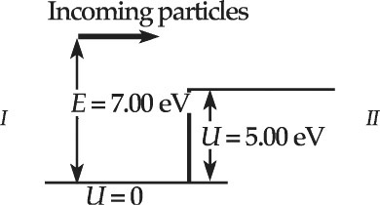



has the solutions

 [region *I*]

 [region *II*]

Check that the solution for region *I* satisfies Schrödinger’s equation:



The last line is true if  which it is because



Therefore, the equation is satisfied in region *I*.

Check that the solution for region *II* satisfies Schrödinger’s equation:



The last line is true if  which it is because



Therefore, the equation is satisfied in region *II*. We apply boundary conditions. Matching functions and derivatives at *x* = 0, we find that

 gives *A* + *B* = *C,*

and  gives 

Then  and .

Incident wave *Aeikx* reflects *Be*–*ikx*, with probability



(b) With *E* = 7.00 eV and *U* = 5.00 eV:



The reflection probability is 

(c) The probability of transmission is 

**P40.46** (a) and (b) The Wave functions are shown in ANS. FIG. P40.46(a) and ANS. FIG. P40.46(b).

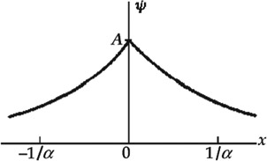 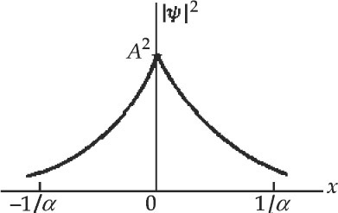

**ANS. FIG. P40.46(a) ANS. FIG. P40.46(b)**

(c) *ψ* is continuous and  as  The function can be normalized. It describes a particle bound near *x* = 0.

(d) Since *ψ* is symmetric,



or 

This gives 

(e) The probability of finding the particle between –1/2 and +1/2 is



**P40.47** (a) Recall from Section 40.7 that the potential energy of a harmonic oscillator is . We can find the energy of the oscillator *E* by substituting the wave function into the Schrödinger equation.



From , we have



Substituting the above into the Schrödinger equation, we have



The last line is true if .

(b) We never find the particle at  because *ψ* = 0 there.

(c) *ψ* is maximized if



which is true at .

(d) We require :



Then,



(e) At , the potential energy is



This is larger than the total energy , so there is  classical probability of finding the particle here.

(f) The actual probability is given by





**P40.48** (a) To find the normalization constant, we note that , or



Noting that



the integral becomes



(b) To determine the relationship between *A* and *B*, we note that . Therefore,



Noting that



and



the integral becomes



The third term is:



so the whole integral is

, giving 

|  |
| --- |
| **ANSWERS TO QUICK-QUIZZES** |

**1.** (d)

**2.** (i) (a) (ii) (d)

**3.** (c)

**4.** (a), (c), (f)

|  |
| --- |
| **ANSWERS TO EVEN-NUMBERED PROBLEMS** |

**P40.2** (a) See ANS. FIG. P40.2; (b) ; (c) 0.865

**P40.4** The photon does not have the smallest possible energy to cause the transition between states *n* = 1 to *n* = 2.

**P40.6** (a) 5.13 × 10−3 eV; (b) 9.41 eV; (c) The electron has a much higher energy because it is much less massive.

**P40.8** (a) 2.00 × 10−9 J; (b) 1.66 × 10−28 m; (c) No. The length of the box would have to be much smaller than the size of a nucleus (~10−14 m) to confine the particle.

**P40.10** See P40.10 for full explanation.

**P40.12** (a) *x* = *L*/4, *L*/2, and 3 *L*/4; (b) We look for sin (3*π x*/*L*) taking on its extreme values 1 and –1 so that the squared wave function is as large as it can be. The result can also be found by studying Figure 40.12b.

**P40.14** (a) 0.332 nm (b) 45.6nm, quite different from 102.6 nm

**P40.16** See P40.16 for full explanation.

**P40.18** (a) *n* = 1: ; ,   
*n* = 2: ; ,   
*n* = 3: ; ;   
(b) See ANS FIG. P40.18(b).

**P40.20** (a) See ANS. FIG. P40.20, (b) 

**P40.22** 

**P40.24** 

**P40.26** (a) See P40.26 (a) for full explanation; (b)  and ;   
(c) first excited state

**P40.28** energy, , degeneracy 1; energy, , degeneracy 3; energy, , degeneracy 6; energy, , degeneracy 10

**P40.30** (a) See P40.30(a) for full explanation; (b) See P40.30(b) for full explanation; (c) 

**P40.32** See P40.32 for full explanation

**P40.34** (a) See P40.34(a) for full proof; (b) For 2 to 1, *λ* = 1.38 *µ*m, infrared; For 3 to 2, *λ* = 827 nm, infrared; For 4 to 1, *λ* = 275 nm, ultraviolet; For 4 to 2, *λ* = 344 nm, near ultraviolet; For 4 to 3, *λ* = 590 nm, yellow-orange visible.

**P40.36** (a) See P40.36(a) for full explanation; (b)  and ;   
(c) first excited state

**P40.38** 

**P40.40** Looking at Figure 40.4, we see that wavelengths for a particle in a finite well are longer than those for a particle in an infinite well. Therefore, the energies of the allowed states should be lower for a finite well than for an infinite well. As a result, the photons from the source have too much energy to be absorbed or, equivalently, the photons have a frequency that is too high. In order to lower their apparent frequency using the Doppler shift, the source would have to move *away* from the particle in the finite square well, not *toward* it.

**P40.42** (a)  (b) *nx* = *ny* = 1; (c) ; (d) *nx* = 1 and *ny* = 2, or *nx* = 2 and *ny* = 1; (e) *nx* = 2 and *ny* = 2; (f) ; (g) ; (h) 

**P40.44** (a) ; (b) ; (c) 49.9 pm; (d) The lithium interatomic spacing of 280 pm is 5.59 times larger. Therefore, it is of the same order of magnitude as the interatomic spacing 2*d* here.

**P40.46** (a) See ANS. FIG. P40.46(a); (b) See ANS. FIG. P40.46(b); (c) *ψ* is continuous and  as  The function can be normalized. It describes a particle bound near *x* = 0; (d)  (e) 0.632

**P40.48** (a) ; (b) 